Submission of your Challenge:
15 Jan (Fri) to 10 Feb (Wed)
Submission of your Challenge's record
10 Feb (Wed) to 3 Mar (Wed)
Chung Chi Challenge Online show
8 to 9pm,14 Mar (Sun)

Fundraising Goals
As a response to the needs of churches and the next generation of scholarships, DSCCC is preparing to expand our teams of teaching staff. The Chung Chi Theological Education Fund has been set up for the recruitment professorial-level teachers who will be appointed as Assistant Professor. The total amount will be approximately HKD6 million.

Fundraising Target: HK$6 Million

Date
Submission of your Challenge:
15 Jan (Fri) to 10 Feb (Wed)
Submission of your Challenge's record (eg. photos, screenshot of your finished miles):
10 Feb (Wed) to 3 Mar (Wed)
Chung Chi Challenge Online show:
14 Mar (Sun)
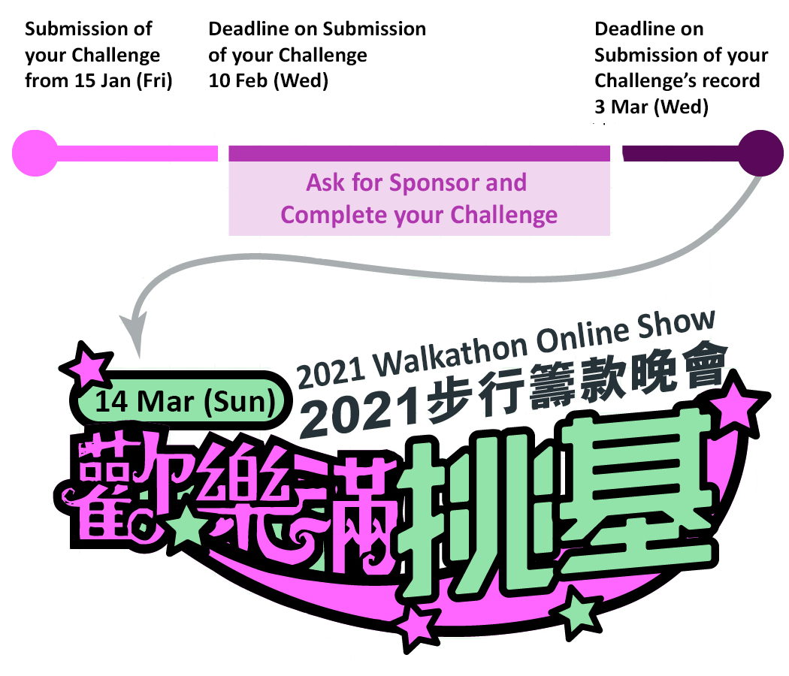

How to raise fund?
Acquiring the Spirit of DSCCC's "Committing to Theological Education Building New Generations of Scholarship Facing Challenges of New Situations", you are encouraged to take up one of the Challenges individually or by group.

How to join "Chung Chi Challenge"?
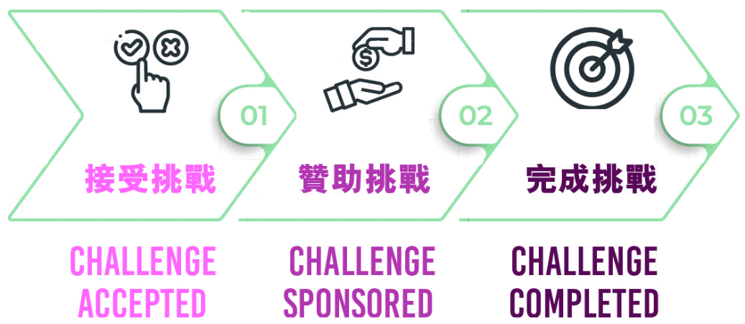
STEP1 | CHALLENGE ACCEPTED
 | Fill in part 1 of this form, select ONE challenge, then send the completed form via email by 10 Feb. If you are not able to join, you are welcome to support us through donations or sponsorship of any challenge. Please refer to Payment Methods as below.
STEP2 | CHALLENGE SPONSORED
 | Please invite sponsors to support you in completing your challenge and email us the sponsorship form (complete part 2 of them form) by 3 Mar.
STEP3 | CHALLENGE COMPLETED
 | Please record the process with your choice of documentary methods (e.g. photos, videos, screen capture of your walking miles, etc.) and email us by 3 Mar. Your submission will be shared on our online show at 8 to 9pm on 14 Mar.

"Chung Chi Challenge"
Pick ONE of the challenges listed below and let us know by 10 Feb. The organising committee may contact you if your challenge requires coordination (such as Writing Gospel of Mark or other Creative Challenges).
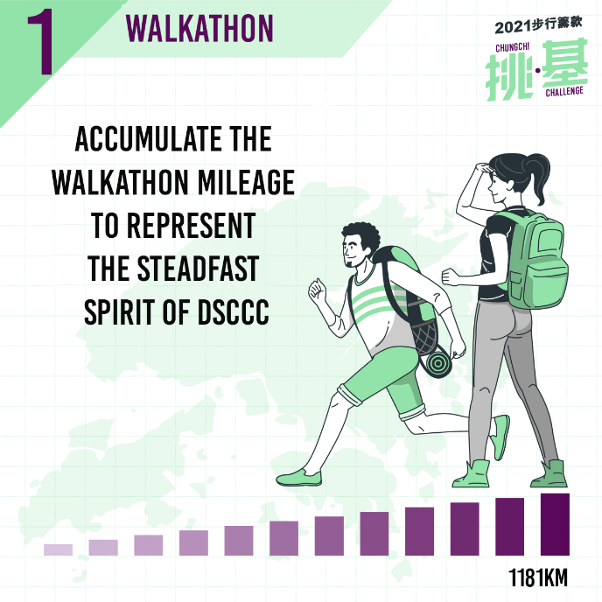 | 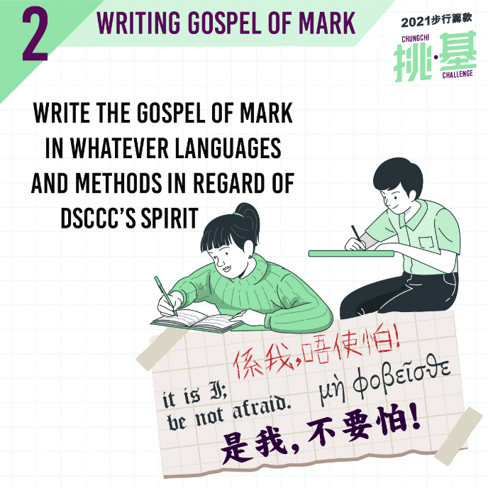
Challenge 1) Walkathon  Let’s accumulate the Walkathon mileage to represent the steadfast spirit of DSCCC in serving Hong Kong. You are invited to contribute your walkathon KM to help us to reach the target of 1181 KM.  1A) Walk Around CUHK  Due to the COVID-19, please walk around CUHK by your own arrangement.  Traditional Walkathon route) : 1.8km  CUHK campus route) (Chung Chi College, New Asia College and Theology Building): 4.2 km  1B) Set your personal goal of Walkathon  Walking, cycling, running treadmill, you name it ! After finishing your walkathon individually or by group at any place by any methods, please keep the records of the KM you earned and send to us. | Challenge 2: Writing Gospel of Mark  In regard of DSCCC's spirit of respecting the Holy Bible, you are invited to write the Gospel of Mark in whatever languages and methods you choose. The committee will contact you to allocate verses to write out in our target to complete a DSCCCer's own copy of the Gospel of Mark. Please complete your writing by 3 Mar and send the digital copy (in pdf or jpg format) to us via email.  Target participants: above 20
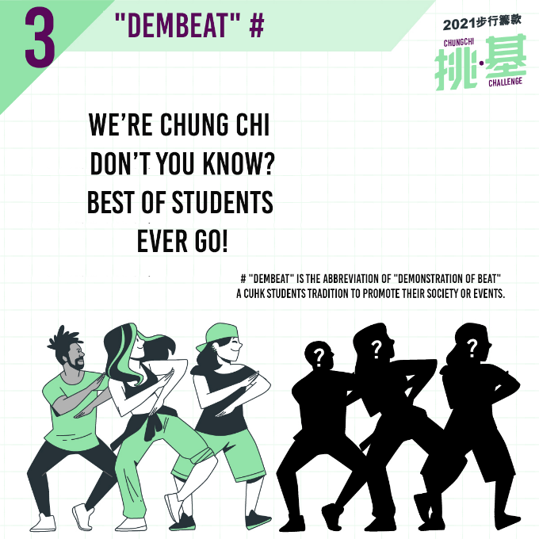
Challenge 3: "DEMBEAT" #  Students are going to design slogans and actions to encourage our professors and special guests to take up the challenges. The number of challenges will be depended on the milestones of the fundraisings. The more the funds available, the more our special guests can join.  Participants: 5-15  # "Dembeat" is the abbreviation of "Demonstration of beat" a CUHK students tradition to promote their society or events. | Challenges 4: Creative Challenge  Your Show Time! You are very welcome to design your own challenge. As we are planning to share your creativity on 14 Mar, please submit your proposals by 10 Feb and the committee will discuss with you in order to plan the online show on 14 Mar.

Payment Methods
Please collect the donations from your sponsors and submit the donations to Divinity School by ONE of the following methods:
Cash
Please submit to the General Office of Divinity School of Chung Chi College during office hours. DO NOT send cash by post.
Cheque
Please make cheques payable to "The Trustees of Chung Chi College" and write "2021Walkathon" on the back of the cheque, then post the cheque with the sponsorship form to Divinity School of Chung Chi College.
E-cheque
Please make cheques payable to "The Trustees of Chung Chi College" and send your PDF e-cheque (issued by bank) together with the sponsorship form to events@theology.cuhk.edu.hk. Please fill "Walk_Your name" in the remark column on your e-cheque.
Bank or Automated Teller Machine (ATM)
Please transfer your donations to the bank account of The Trustees of Chung Chi College (Hang Seng Bank, Account number：283-174001-001) then post the original copy of your bank slip together with sponsorship form to the Divinity School of Chung Chi College.
Online Bank Transfer
Please transfer your donations to the bank account of The Trustees of Chung Chi College (Hang Seng Bank, Account number：283-174001-001) then email the transfer record (save file in PDF or screenshot of the completed page, which clearly shows the bank account number, amount, date and time) to events@theology.cuhk.edu.hk.
Credit card（1%-3% of commission will be charged by bank and card issuer ^）
Please make an online donation at Chung Chi College Online Donation Form and select to support "崇基學院神學院Divinity School of Chung Chi College" at donation details, then email the screenshot of the completed page after payment (clearly showing the date, time, amount, name, and reference number) and sponsorship form to events@theology.cuhk.edu.hk.
^ Donation will be transferred to Divinity School after the deduction of the commission.

Donations over HK$100 are tax-deductible with an official receipt. Please select "Yes" on the sponsorship form if your sponsor(s) request for an official receipt. Receipts will be sent to you within 3 months upon completion of the Walkathon, so please distribute the receipts to your sponsors.
Mailing address
c/o: Walkathon, Divinity School of Chung Chi College, The Chinese University of Hong Kong, Shatin, Hong Kong.
Inquiry
Phone or WhatsApp: (852) 39436708
Email: events@theology.cuhk.edu.hk
Follow us on Facebook (content in Chinese)
Search “dscccwalkathon”

Part 1: Ready to pick a Challenge?
☐ Staff or Council member ☐Alumni ☐Student, Proramme: _______________ ☐Other

Name:  (Block letter) |  | Title: | Prof./ Dr./Rev./ Mr./Ms./Other: ____
Contact No.: |  | Email:
Affiliated Church:
I will join the Challenge of:
☐1. Walkathon, Estimated mileage to complete: KM
☐2. Writing the Gospel of Mark
☐3. DEMBEAT
☐4. Creative Challenge: Please tell us your plan:

☐ I will join the challenge by group
Group Name: |  | Contact Person:
Contact No.: |  | Contact Email:

I am not able to attend the event but I would like to donate the following amount to support the Divinity School:
○ HK$1000 ○ HK$500 ○ HK$3000 ○ Other, please specify: ____________________________
Donation Receipt(s): ○ By post, mailing address:_______________________________________
○ Collet at general office
Office use only  Checker: ________________________________  Date: ___________________________________ | No: _________________  Received by: __________________________________  Total Amount: ________________________________
Payment Method: Cash/ Cheque/ Other: _____________________________________________________________

Please complete part 1 and send us via email to events@theology.cuhk.edu.hk by 10 Feb
Part 2: Walkathon Sponsorship Form
- Please record and collect the donation from sponsor(s).
- Please submit this form with the donation by any payment methods listed above.
- For donation over HK$100 may require for an official receipt for tax deduction. Please fill “YES” in the box of “Receipt” you need a receipt. Receipt(s) will be issued and sent to participants within 3 months after the event.

Name of Sponsor | Contact No. | Amount (HKD) | Receipt required | Name of Sponsor | Contact No. | Amount (HKD) | Receipt required
 |  |  |  | 11.
 |  |  |  | 12.
 |  |  |  | 13.
 |  |  |  | 14.
 |  |  |  | 15.
 |  |  |  | 16.
 |  |  |  | 17.
 |  |  |  | 18.
 |  |  |  | 19.
 |  |  |  | 20.
 |  |  |  | TOTAL AMOUNT:

Donation Receipt(s): ○ By post, mailing address:_____________________________________________
○ Collet at general office
Office use only  Checker: ________________________________  Date: ___________________________________ | No: _________________  Received by: __________________________________  Total Amount: ________________________________
Payment Method: Cash/ Cheque/ Other: _____________________________________________________________

Please complete part 2 and collect donations,
then send us via email to events@theology.cuhk.edu.hk by 3 mar.
Don’t forget to send us your challenge’s record by 3 Mar as well!

